# 

# Joint 1:

# Joint 2:

# Joint 3:

## Motor

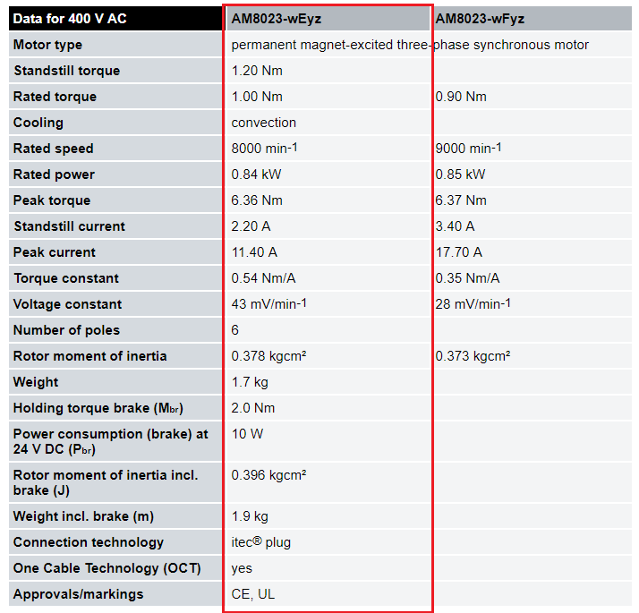

## Gearbox

